Tomcat Server – Deploy a web app on tomcat server

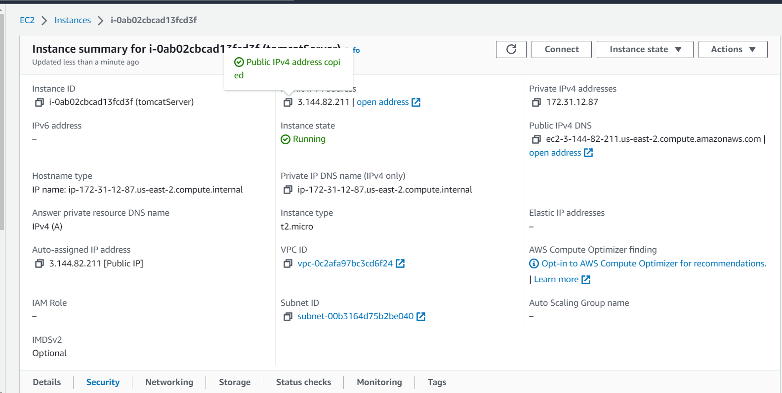

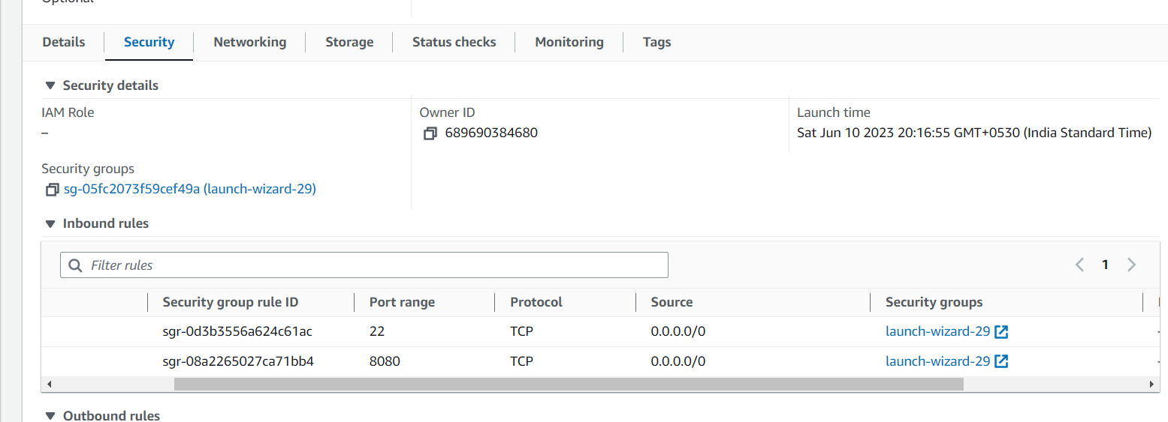

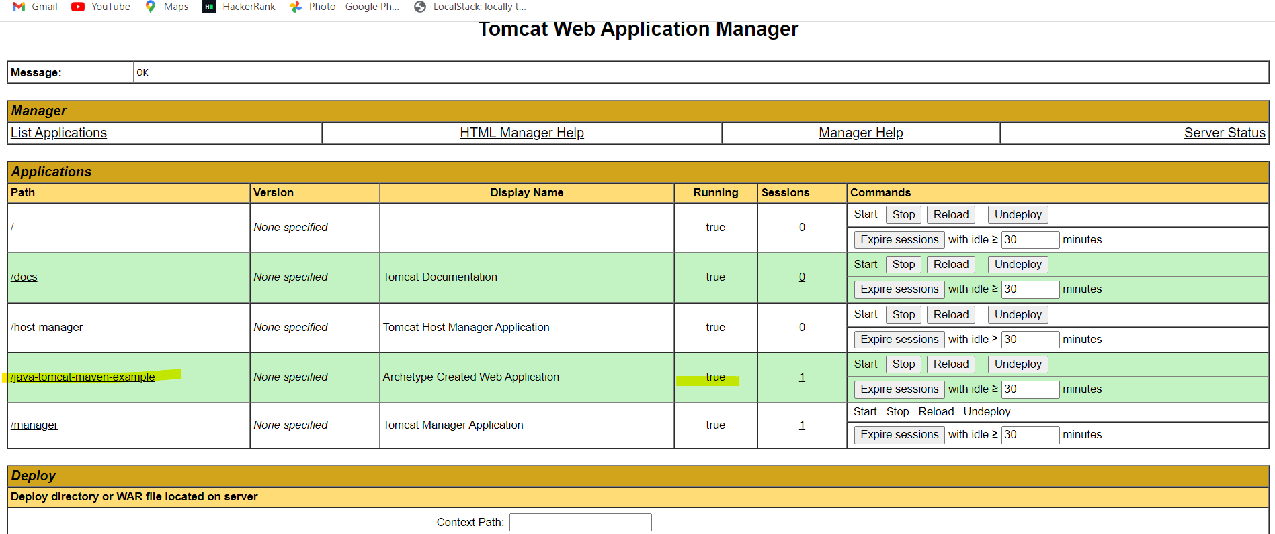

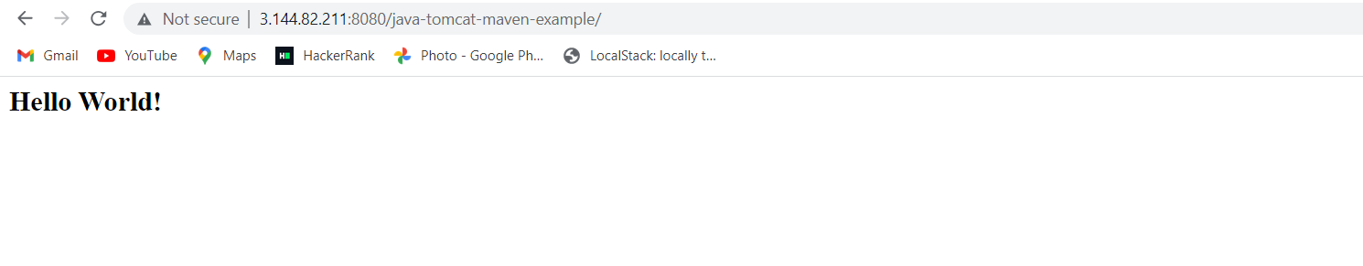

Create VPC

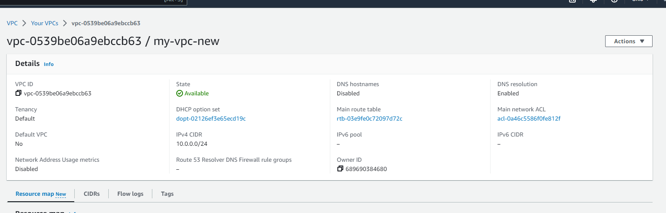

Create internet gateway and attach it to VPC

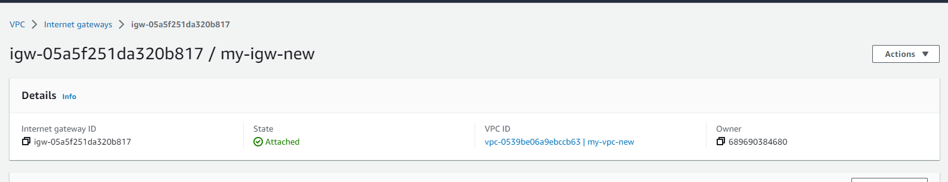

Create Public subnet

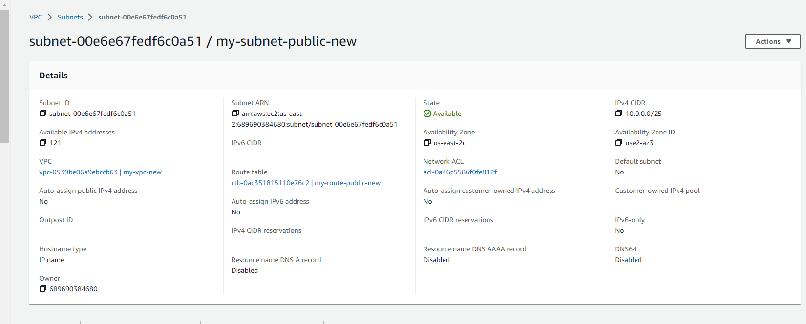

Create route table for public subnet and attach internet gateway

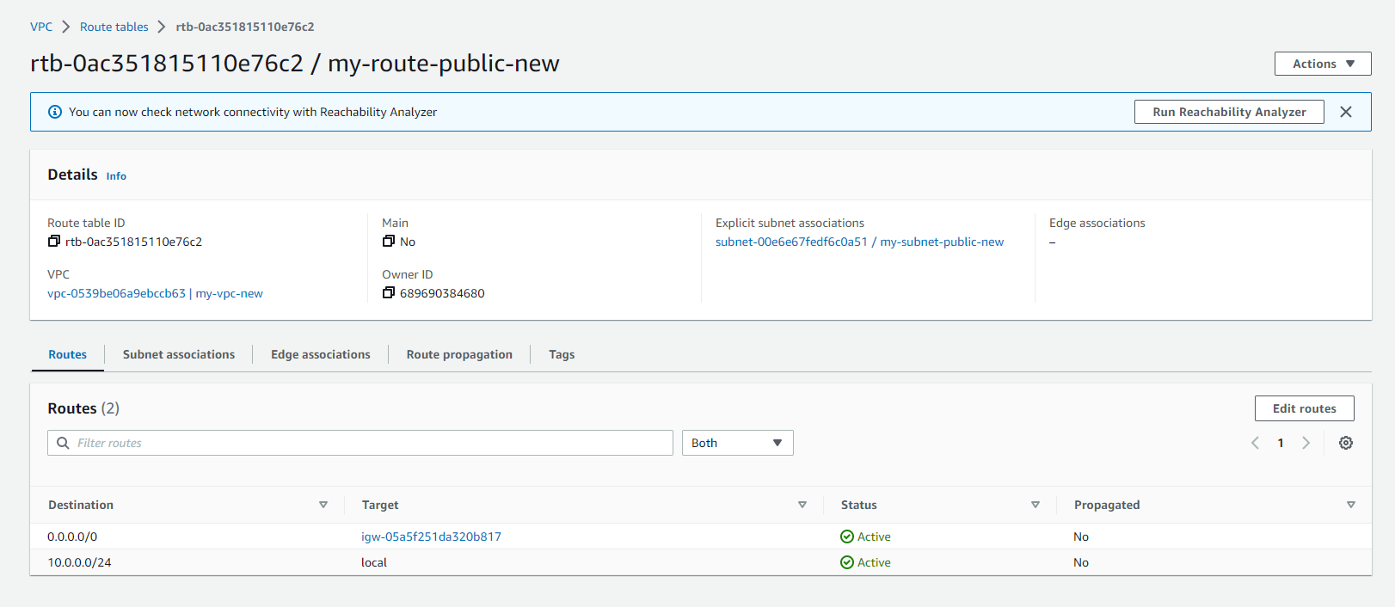

Create private subnet

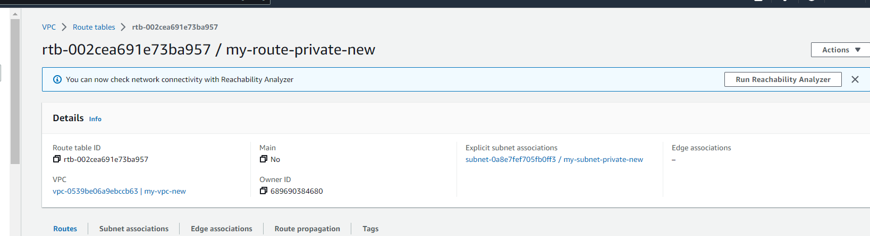

Create nat gateway for public subnet

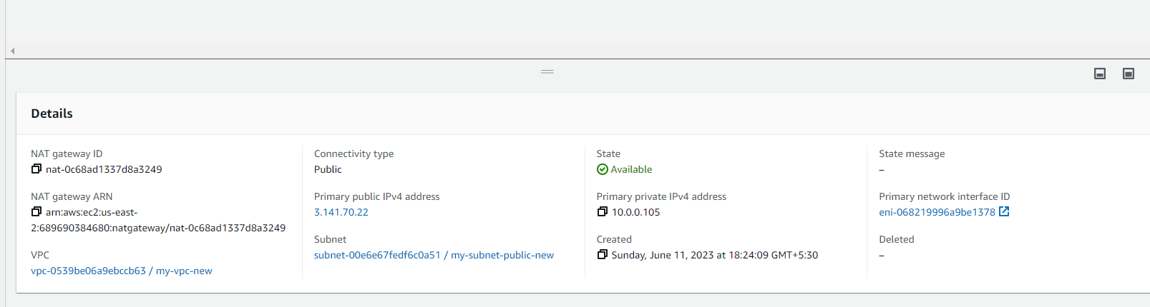

Create private route table and attach nat gateway

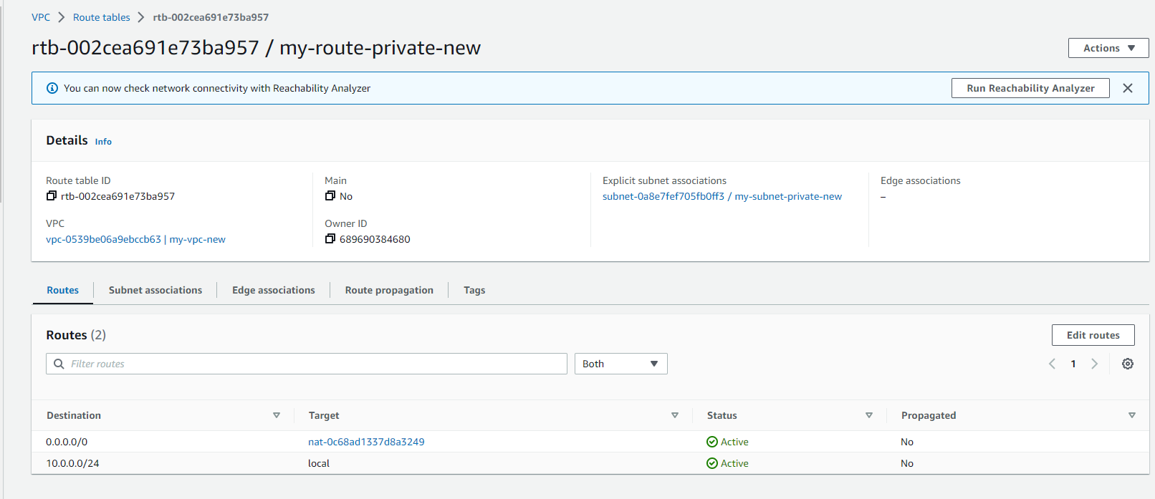

VPC map

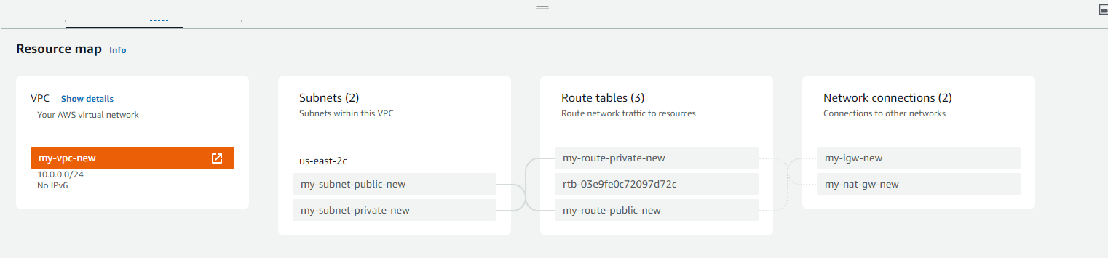

Launch EC2 instances in public and private subnet

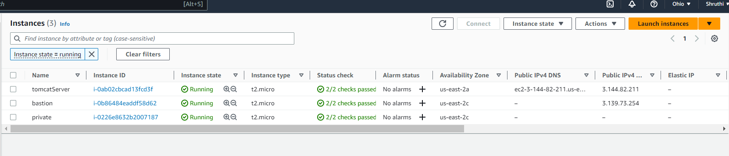

EC2 in Public subnet(Bastion)

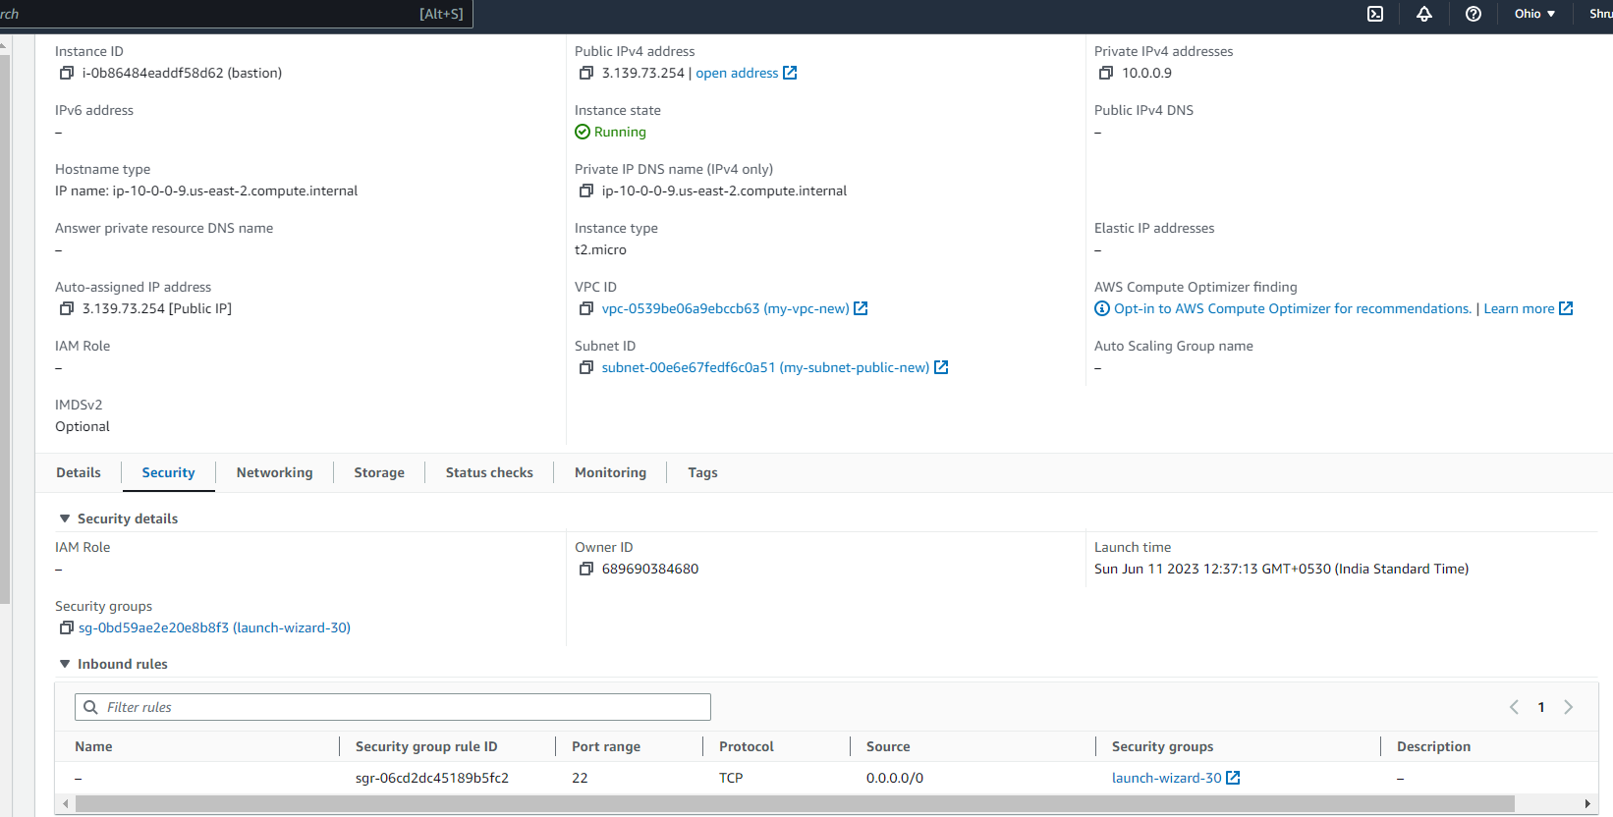

EC2 instance in private subnet

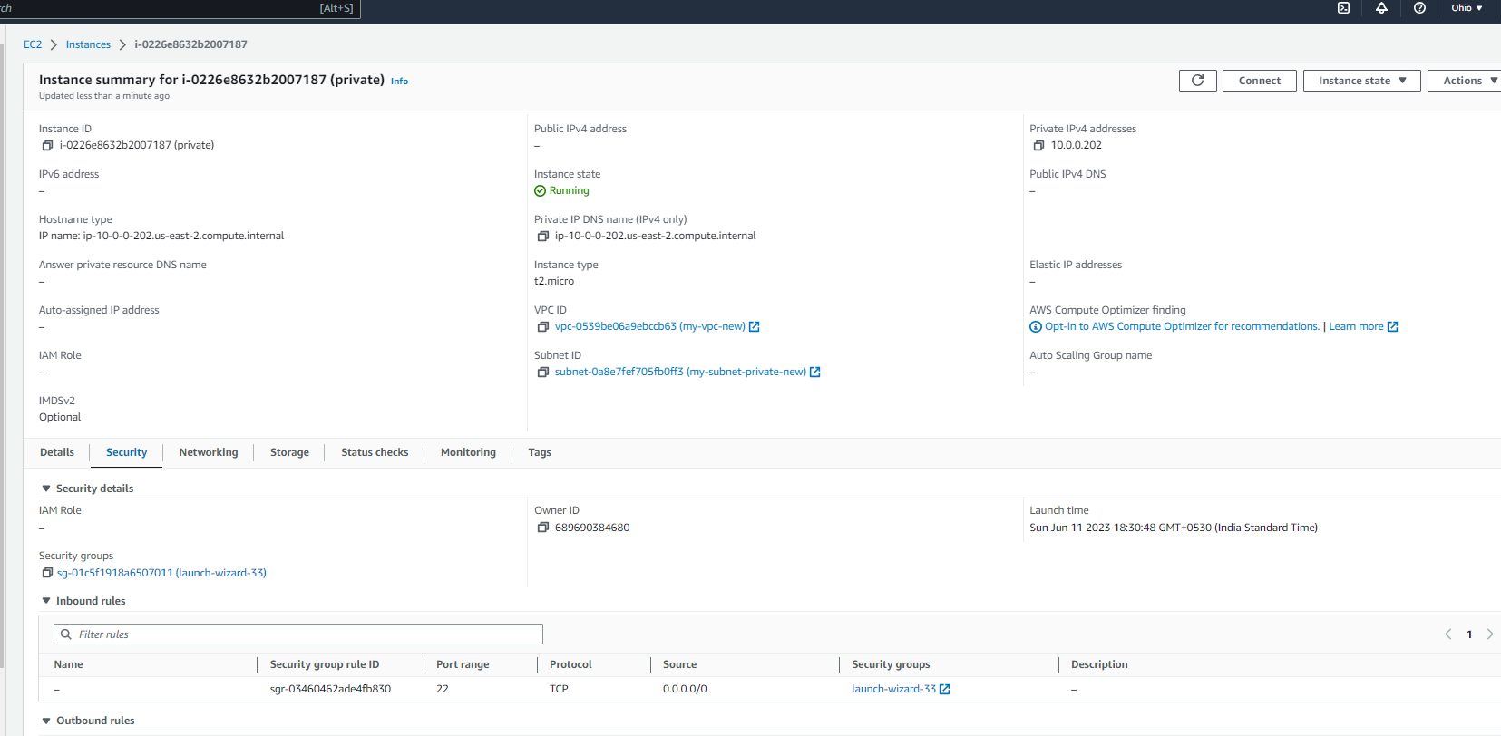

Connect to EC2 in public subnet

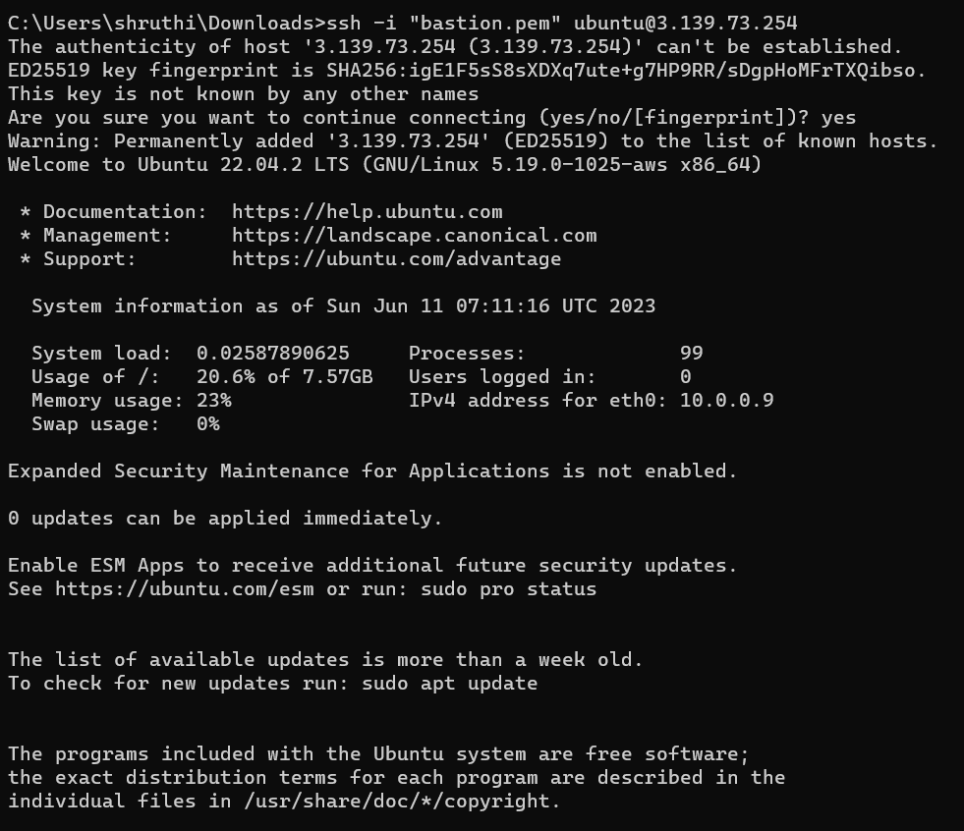

Copy private pem key and ssh into private subnet EC2 instance

